1. Mismatch column name display in list grid 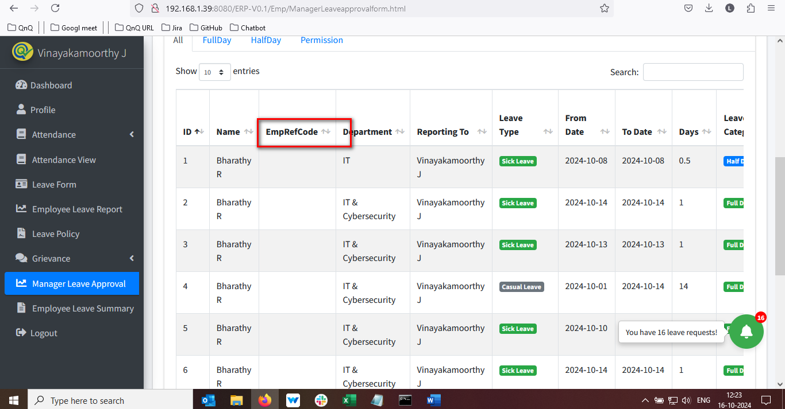 //

Column value not display